**Getting your hands dirty with Embedded: An introduction to Arduino**

Table of Contents

1. Birth of MCU/ Microprocessor
2. A friendly introduction to Arduino
3. Arduino sketch and Internals
4. GPIO’s
5. Blinking led example
6. Display your name on lcd: Intro to Liquid crystal display
7. User defined functions

References:

* <http://forefront.io/a/beginners-guide-to-arduino>

1. Birth of MCU/ Microprocessor
2. Introduction to Arduino
   1. What is Arduino

 Arduino is an open-source electronics prototyping platform based on flexible, easy-to-use hardware and software. It's intended for artists, designers, hobbyists, and anyone interested in creating interactive objects or environments.

Source: http://www.arduino.cc/

* 1. What is microcontroller

A microcontroller is a compact [microcomputer](http://whatis.techtarget.com/definition/microcomputer) designed to govern the operation of [embedded system](http://searchenterpriselinux.techtarget.com/definition/embedded-system)s in motor vehicles, [robots](http://searchcio-midmarket.techtarget.com/definition/robot), office machines, complex medical devices, mobile radio transceivers, vending machines, home appliances, and various other devices. A typical microcontroller includes a [processor](http://searchcio-midmarket.techtarget.com/definition/processor), [memory](http://searchmobilecomputing.techtarget.com/definition/memory), and [peripherals](http://searchmobilecomputing.techtarget.com/definition/peripheral).

* 1. Which Arduino board we are going to use

The Arduino Duemilanove is a microcontroller board based on Atmel ATmega328. It has 14 digital input/output pins (of which 6 can be used as PWM outputs), 6 Analog inputs, a 16 MHz crystal oscillator, a USB connection, a power jack, an ICSP header, and a reset button.

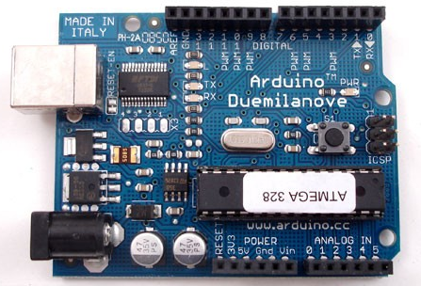

"Duemilanove" means 2009 in Italian and is named after the year of its release.

Summary of features provided by Duemilanove:

|  |  |
| --- | --- |
| Microcontroller | ATmega328 |
| Operating Voltage | 5V |
| Input Voltage (recommended) | 7-12V |
| Input Voltage (limits) | 6-20V |
| Digital I/O Pins | 14 (of which 6 provide PWM output) |
| Analog Input Pins | 6 |
| Communication Interface | UART (Serial RX/TX), SPI, I2C. |
| Programming Interface | USB (using bootloader), ICSP(SPI) |
| DC Current per I/O Pin | 40 mA |
| DC Current for 3.3V Pin | 50 mA |
| Flash Memory | 32 KB (ATmega328) of which 2 KB used by boot loader |
| SRAM | 2 KB (ATmega328) |
| EEPROM | 1 KB (ATmega328) |
| Clock Speed | 16 MHz |

Power

The Arduino Duemilanove can be powered via the USB connection or with an external power supply.

The power source is selected automatically. External (non-USB) power can come either from an AC-to-DC adapter or battery.

The board can operate on an external supply of 6 to 20 volts. If supplied with less than 7V, however, the 5V pin may supply less than five volts and the board may be unstable. If using more than 12V, the voltage regulator may overheat and damage the board. The recommended range is 7 to 12 volts.

Memory

The ATmega328 has 16 KB of flash memory for storing code (of which 2 KB is used for the bootloader).

Input and Output

Each of the 14 digital pins on the Duemilanove can be used as an input or output, using [pinMode()](http://arduino.cc/en/Reference/PinMode), [digitalWrite()](http://arduino.cc/en/Reference/DigitalWrite), and [digitalRead()](http://arduino.cc/en/Reference/DigitalRead) functions. They operate at 5 volts. Each pin can provide or receive a maximum of 40 mA and has an internal pull-up resistor (disconnected by default) of 20-50 K-Ohms.

In addition, some pins have specialized functions as mentioned below

1. **Serial: 0 (RX) and 1 (TX)**

Used to receive (RX) and transmit (TX) TTL serial data. These pins are connected to the corresponding pins of the FTDI USB-to-TTL Serial chip.

1. **External Interrupts: 2 and 3**

These pins can be configured to trigger an interrupt on a low value, a rising or falling edge, or a change in value. See the [attachInterrupt()](http://arduino.cc/en/Reference/AttachInterrupt) function for details.

1. **PWM: 3, 5, 6, 9, 10, and 11**

Provide 8-bit PWM output with the [analogWrite()](http://arduino.cc/en/Reference/AnalogWrite) function. These pins can also be used as GPIOs.

1. **SPI: 10 (SS), 11 (MOSI), 12 (MISO), 13 (SCK)**

These pins support SPI communication using the [SPI library](http://arduino.cc/en/Reference/SPI).

1. **LED: 13**

There is a built-in LED connected to digital pin 13. When the pin is HIGH value, the LED is on, when the pin is LOW, it's off.

The Duemilanove has 6 Analog inputs, each of which provides 10 bits of resolution (i.e. 1024 different values). By default they measure from ground to 5 volts, though is it possible to change the upper end of their range using the AREF pin and the [analogReference](http://arduino.cc/en/Reference/AnalogReference)() function.

Additionally, some pins have specialized functionality:

1. **I2C: Analog input pins A4 (SDA) and A5 (SCL)** Support I2C (TWI) communication using the [Wire library](http://arduino.cc/en/Reference/Wire).

There are a couple of other pins on the board:

* + - 1. **AREF**

This is reference voltage for the Analog inputs. Used with [analogReference](http://arduino.cc/en/Reference/AnalogReference)().

* + - 1. **Reset**

Bring this line LOW to reset the microcontroller.

SETUP and LOOP brief Introduction

Source: http://arduino.cc/en/Reference/HomePage

Arduino Commands

Setup

|  |  |
| --- | --- |
| **Command** | **Explanation and usage** |
| pinMode( pin , mode ) | Used to direct given Arduino pin as Input or Output  Ex : pinMode(13, OUTPUT); //would set Arduino pin 13 as output  Ex : pinMode(13, INPUT); //would set Arduino pin 13 as input |
| **Serial-UART** | **Universal Asynchronous Receiver Transmitter** |
| Serial.begin(baudrate) | Used to initialize serial communication. Input is baud rate at which communication takes place. By default baud rate is configures to 9600. |

Loop

|  |  |
| --- | --- |
| **Command** | **Explanation and usage** |
| **GPIO’s** | **General Purpose Input Output** |
| digitalWrite( pin, value) | Write a HIGH (+5V) or a LOW (+0V) value to a digital pin  Ex: digitalWrite(13, HIGH); // would set the pin 13 as HIGH(5V) |
| digitalRead( pin ) | Used to read the status of pin which is defined in input mode using pinMode command. |
| **Delay** | **Delay Functions** |
| delay( ms ) | ms: the number of milliseconds to pause (unsigned long)  Ex: delay(1000); // waits for 1000 millisecond |
| **ADC** | **Analog to Digital Convertor** |
| analogRead(pin) | Reads the value from the specified Analog pin and returns integer (0-1023)  Ex: value = analogRead(3); // read the pin 3 and save the value in value |
| analogReference(type) | Configures the reference voltage used for Analog input (i.e. the value used as the top of the input range). The options are:   * DEFAULT: the default Analog reference of 5 volts (on 5V Arduino boards) * EXTERNAL: the voltage applied to the AREF pin (0 to 5V only) is used as the reference. |
| **PWM** | **Pulse Width Modulation** |
| analogWrite(pin, value) | The frequency of the PWM signal on most pins is approximately 490 Hz  Pin: the pin to write to.  Value: the duty cycle: between 0 (always off) and 255 (always on).  Ex: analogWrite(9, 255); // analogWrite values from 0 to 255 |
| **Serial –UART** |  |
| Serial.write(byte) | Byte: Character byte supposed to be sent through serial communication. |

Arduino Duemilanove Pin out Diagram

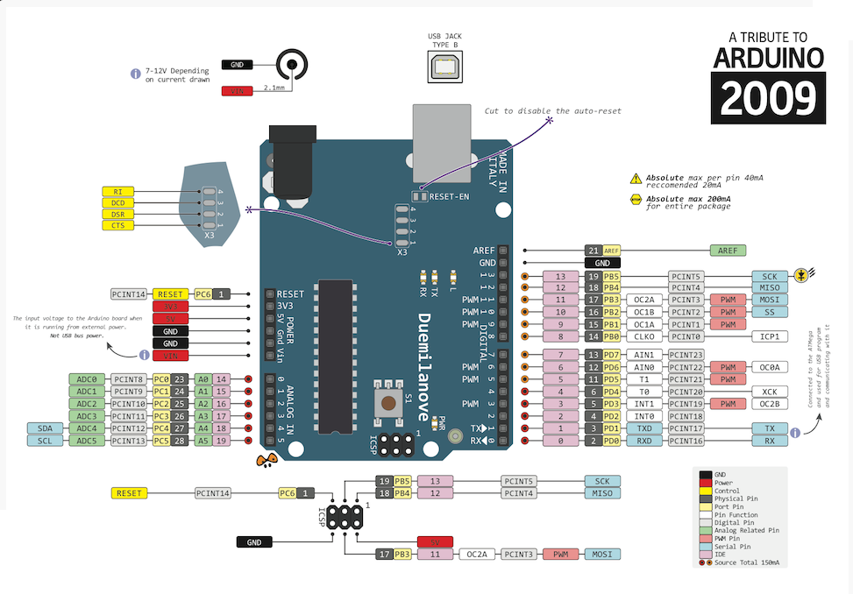

Source: <http://arduino.cc/en/Main/arduinoBoardDuemilanove>

1. Arduino sketches and internals

Arduino IDE Version 0022 works smoothly with Arduino Duemilanove ([Link](https://arduino.googlecode.com/files/arduino-0022.zip)).

Steps for using the Arduino IDE are mentioned below:

* + - 1. Start with new Arduino sketch

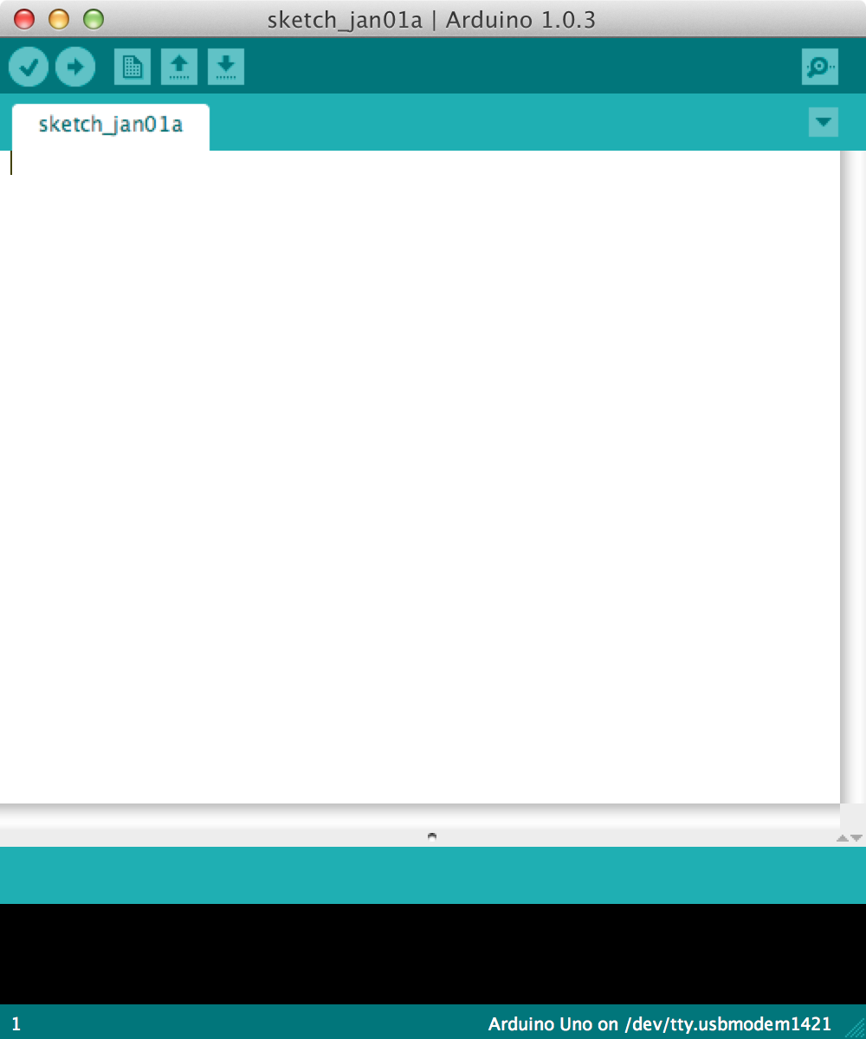

* + - 1. Initial setup:

Select the board Go to **Tools** menu and select **Board**

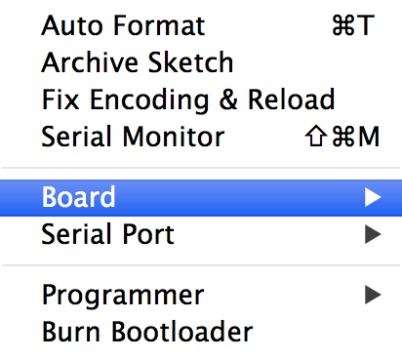

Then select the type of Arduino you want to program, in our case it’s the **Arduino** Duemilanove.

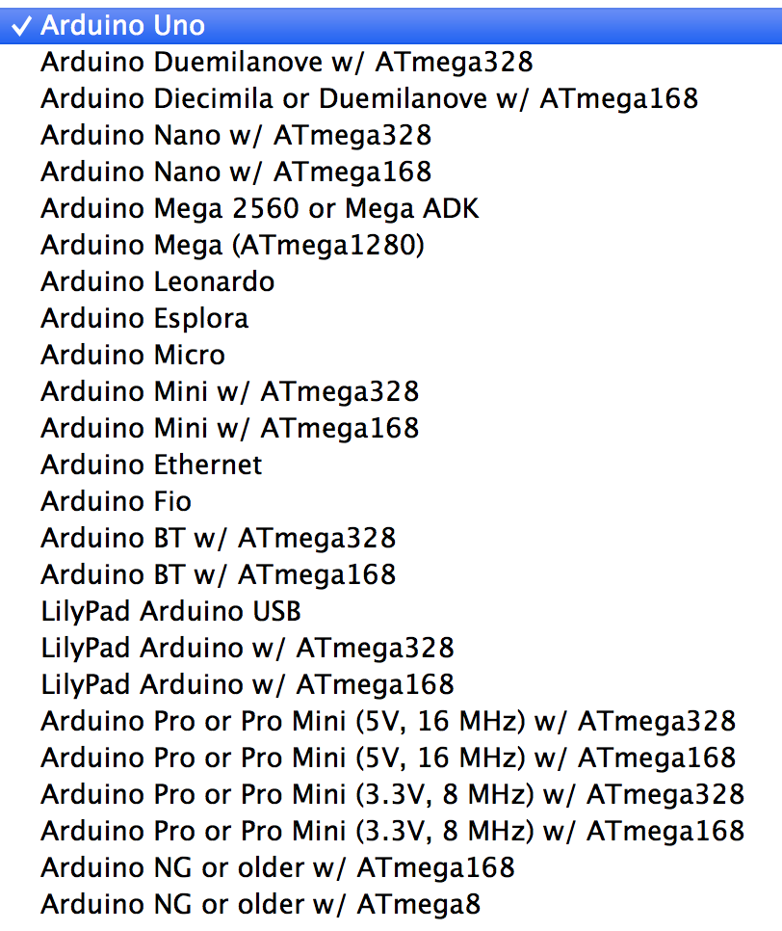

1. The Code

The codes you write for your Arduino are known as **sketches**. Every sketch needs two void type functions, setup() and loop(). A void type function doesn’t return any value. The setup() method is ran once at the just after the Arduino is powered up and the loop()method is ran continuously afterwards. The setup() is where you want to do any initialisation steps, and in loop() you want to run the code you want to run over and over again.

So, your basic sketch or program should look like this:

**void** setup**()**

**{**

**}**

**void** loop**()**

**{**

**}**

1. Blinking LED example

The onboard LED we want to control is on pin 13. In our code above the setup() method let’s create a variable called ledPin. In Arduino we need to state which type our variable is beforehand, in this case it’s an integer, so it’s of type int.

**int** ledPin **=** **13;**

**void** setup**()**

**{**

**}**

**void** loop**()**

**{**

**}**

Each line is ended with a semicolon (;).

In the setup() method we want to set the ledPin to the output mode. We do this by calling a special function called pinMode() which takes two variables, the first the pin number, and second, whether it’s an input or output pin. Since we’re dealing with an output we need to set it to a constant called OUTPUT. If you were working with a sensor or input it would be INPUT.

**int** ledPin **=** **13;**

**void** setup**()**

**{**

pinMode**(**ledPin**,** OUTPUT**);**

**}**

**void** loop**()**

**{**

**}**

In our loop we are going to first switch off the LED to make sure our program is being transferred to the chip and overriding the default.

We do this by calling another special method called digitalWrite(). This also takes two values, the pin number and the level, HIGH or the on state or LOW the off state.

**int** ledPin **=** **13;**

**void** setup**()**

**{**

pinMode**(**ledPin**,** OUTPUT**);**

**}**

**void** loop**()**

**{**

digitalWrite**(**ledPin**,** LOW**);**

**}**

Next we want to compile to machine code and deploy or *upload* it to the Arduino.

1. Compiling the Code

Go to **Sketch** select **Verify/Compile** the sketch will start compiling

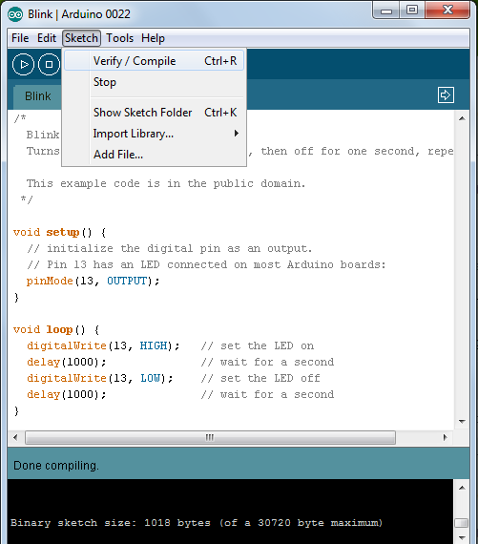

Selecting COM port for Arduino board:

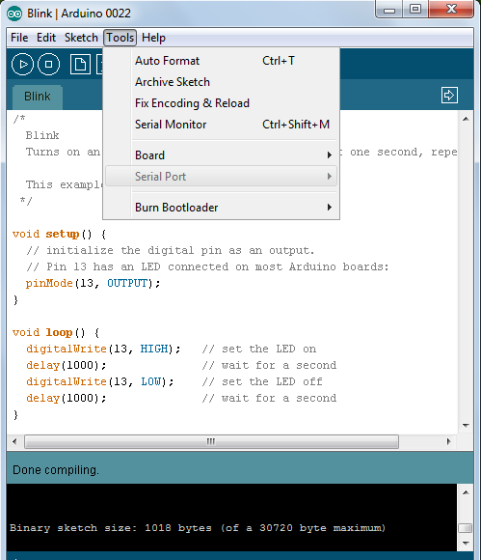

Press upload button to load firmware (hex file) in to flash memory.

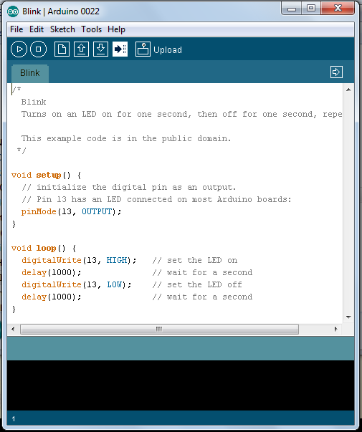

1. Interfacing 16x2 Character LCD (Driver: HD44780 Hitachi)

Steps:

1. Connect the LCD as shown in snapshot below.

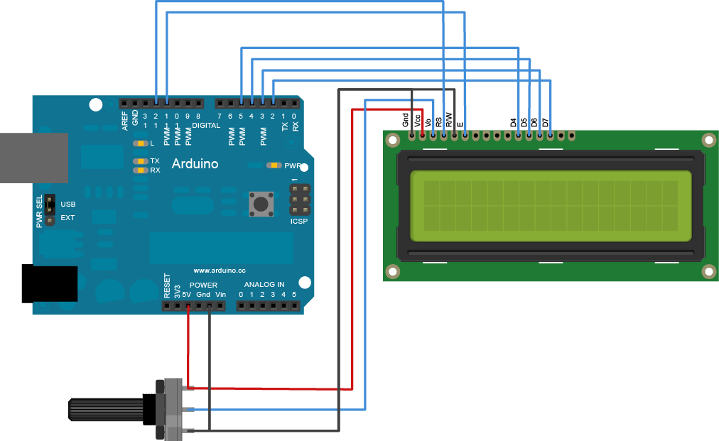

In a more detailed manner below:

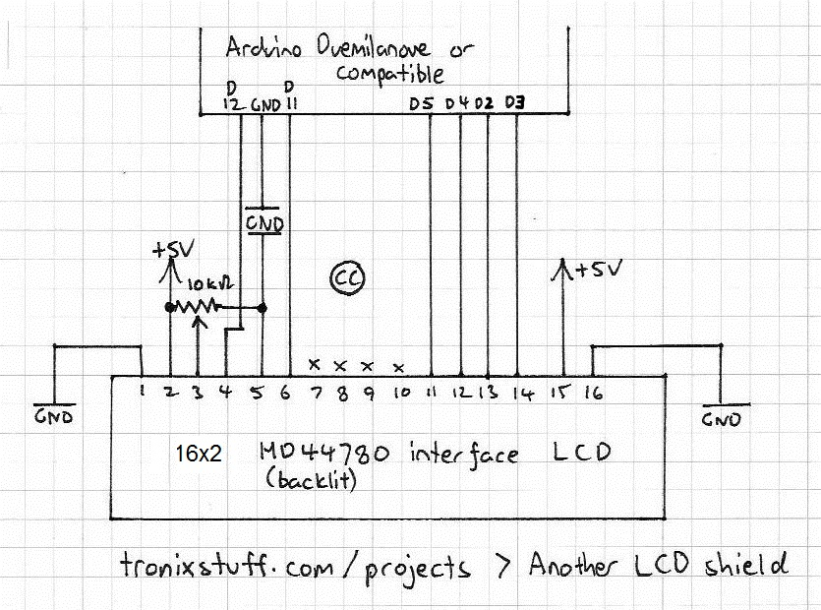

1. Example Code to display “Hello world”

*Source: http://www.arduino.cc/en/Tutorial/LiquidCrystal*  
  
*// include the library code:*  
#include <LiquidCrystal.h>  
  
*// initialize the library with the numbers of the interface pins*  
LiquidCrystal lcd(12, 11, 5, 4, 3, 2);  
  
void **setup**()

{  
  *// set up the LCD's number of columns and rows:*  
 lcd.begin(16, 2);  
  *// Print a message to the LCD.*  
 lcd.print("hello, world!");  
}

void **loop**()

{  
 *// set the cursor to column 0, line 1*  
  *// (note: line 1 is the second row, since counting begins with 0):*  
 lcd.setCursor(0, 1);  
  *// print the number of seconds since reset:*  
 lcd.print(millis()/1000);  
}

1. Functions for Character LCD

lcd.begin(cols, rows) :

Description: Initializes the interface to the LCD screen, and specifies the dimensions (width and height) of the display. begin() needs to be called before any other LCD library commands.

Syntax: lcd.begin(cols, rows)

Parameters

cols: the number of columns that the display has

rows: the number of rows that the display has

i.e. 16x2 or 20x4.

lcd.print(data) :

Description

Prints text to the LCD.

Syntax

lcd.print(data)   
lcd.print(data, BASE)

Parameters

data: the data to print (char, byte, int, long, or string)

BASE (optional): the base in which to print numbers: BIN for binary (base 2), DEC for decimal (base 10), OCT for octal (base 8), HEX for hexadecimal (base 16).

lcd.setCursor(col, row) :

Description

Position the LCD cursor; that is, set the location at which subsequent text written to the LCD will be displayed.

Syntax

lcd.setCursor(col, row)

Parameters

col: the column at which to position the cursor (with 0 being the first column)

row: the row at which to position the cursor (with 0 being the first row)

Reference: <http://arduino.cc/en/Reference/LiquidCrystal>

1. Writing User Defined functions

There are two required functions in an Arduino sketch, setup() and loop(). Other functions must be created outside the brackets of those two functions. As an example, we will create a simple function to multiply two numbers.

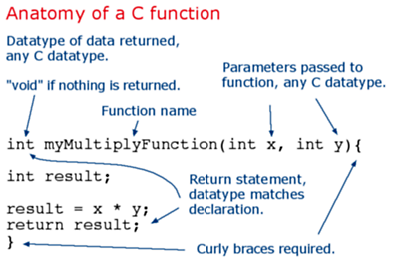

Reference for data types: look for Data type under variable <http://arduino.cc/en/Reference/HomePage>

User defined Function’s need to declared outside any other function, and can go either above or below the "loop()" function.

To "call" user defined function, we pass it parameters of the data type that it is expecting:

Example of the above used defined function “myMultiplyFunction”:

Source: <http://arduino.cc/en/Reference/FunctionDeclaration>

void **setup**()

{

Serial.begin(9600); // Default baud rate

}

void **loop**()

{

int i = 2;

int j = 3;

int k;

k = myMultiplyFunction(i, j); // calling user defined function

Serial.println(k);

delay(500);

}

int myMultiplyFunction(int x, int y){

int result;

result = x * y;

return result;

}